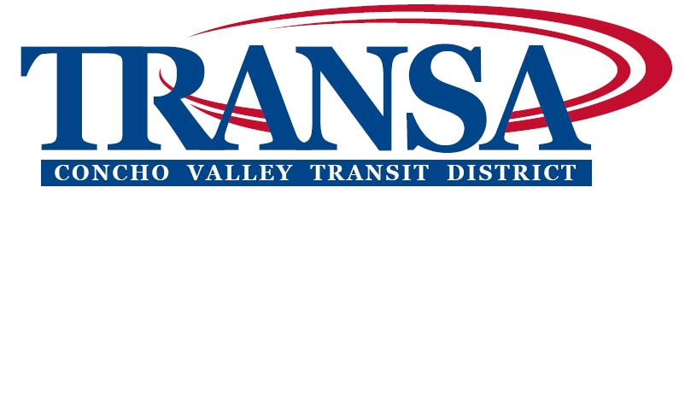

DESIGNATION OF
CONCHO VALLEY TRANSIT DISTRICT

BOARD MEMBER

The City Council for the City of San Angelo, Texas met on , and designated , ,
and , to be their representing members on the Concho Valley Transit District Board.

ATTEST:
Mayor Name & Title

******

Please return to: Concho Valley Council COG, P.O. Box 60050, San Angelo, TX 76906

Please indicate below the mailing address and phone number where the member wishes to receive CVTD mail and telephone contacts.

email – optional

cell – optional

