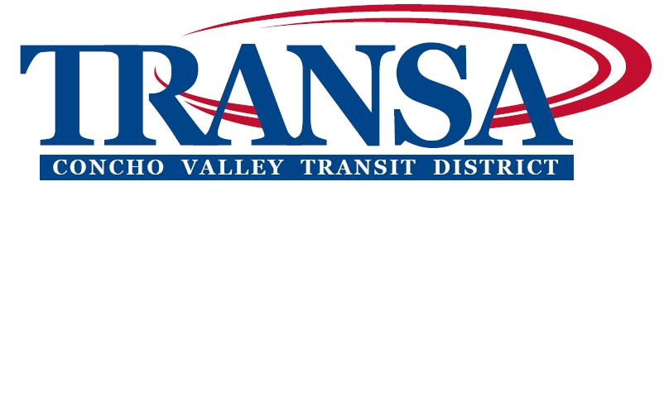
Concho Valley Transit District (CVTD)
Minutes of Meeting for September 12, 2012
The Concho Valley Transit District met on Wednesday, September 12, 2012 in the Concho Valley Regional Conference and Training Center, 2801 W. Loop 306, Suite A, San Angelo, TX.
Board members present:
Allen Amos, Concho County Judge, Chairman
Michael D. Brown, Tom Green County Judge, Vice Chairman
Ralph Sides, Sterling County Judge, Secretary
Roy Blair, Coke County Judge
Charlie Bradley, Schleicher County Judge
Fred Deaton, Crockett County Judge
Larry Isom, Reagan county Judge
Andrew Murr, Kimble County Judge
John Nanny, Irion County Commissioner
Danny Neal, McCulloch County Judge
Miguel Villanueva, Sutton County Commissioner

Board members not present:
Fredd B. Adams, City of San Angelo Council Member
Paul Alexander, City of San Angelo Council Member
Richard Cordes, Menard County Judge
Johnny Silvas, City of San Angelo Council Member

Call to Order
Chairman Allen Amos announced the presence of a quorum and called the meeting to order at 3:02 PM.
Invocation and Pledge of Allegiance
Judge Andrew Murr gave the invocation and Judge Allen Amos led the Pledge of Allegiance.

Approval of Minutes
Upon a motion by Commissioner Miguel Villanueva, seconded by Judge Danny Neal, the minutes of the August 8, 2012 meeting were unanimously approved.

Approval of checks in excess of $2,000 written since the last meeting
Tracy Ogle informed the board that document number 13159 on the list was a duplicate and was voided. Upon a motion by Commissioner John Nanny, seconded by Judge Andrew Murr, CVTD checks in excess of $2,000 written since the last meeting were unanimously approved.

DISCUSSION & AUTHORIZATION for CVTD Executive Director to accept TXDOT administered federal funds for Rural State of Good Repair to replace vehicles
Jeffrey Sutton asked Delma Childress to address the board about this item. Delma informed the board that the funding came from 5309 Bus and Bus Facilities Program. The CVTD was able to apply on the urban and rural side. TXDOT submitted the application for the rural side and Sean applied on the urban side. The CVTD was awarded $760,000 to replace rural vehicles and $860,800 to replace urban vehicles. Rebekah Dominguez notified the board that the transit district anticipated purchasing three new heavy duty low floor buses for fixed route, nine medium duty low floor demand response vehicles, and five low floor mini vans. Jeffrey Sutton notified the board that Sean Scott is out of town looking into buses to purchase because the CVTD was awarded these funds. He also asked the board to keep in mind that the CVTD will be selling buses and to make room in their budgets if they anticipated needing one. Motion by Judge Danny Neal second by Judge Larry Isom, the board unanimously approved accepting TXDOT administered funds for Rural State of Good Repair to replace vehicles.

DISCUSSION & AUTHORIZATION for CVTD Executive Director to accept federal funds for Urban State of Good Repair to replace vehicles
Tracy Ogle notified the board that the back-up for this resolution was behind the last agenda item. Nancy Pahira asked Delma Childress if this amount would be matched by Transportation Development Credits (TDC’s). She informed the board that the CVTD submitted an application for TDC’s and would know in November if they were awarded so they would not need local match. Motion by Judge Fred Deaton second by Judge Andrew Murr, the board unanimously approved accepting federal funds for Urban State of Good Repair to replace vehicles.

DISCUSSION & AUTHORIZATION for CVTD Executive Director to accept additional TXDOT administered funds for 5311 operating expenses
Judge Andrew Murr asked why the amount was so high and if it was because the CVTD is buying buses. Nancy Pahira explained that the $92,376 was going to be used in operating. Motion by Judge Larry Isom second by Andrew Murr, the board unanimously accepting additional TXDOT administered funds for 5311 operating expenses.

DISCUSSION & AUTHORIZATION for CVTD Executive Director to obtain line of credit for operating expenses
Upon a motion by Judge Sides resolution 091212D a resolution authorizing the Executive Director to open a Revolving Line of Credit for operating expenses with the stipulation that the line of credit will be paid off and closed pending payment from the City of San Angelo to the CVTD or no later than December 31, 2012, and the line of credit will no longer exist unless voted on by this board. This motion was seconded by Judge Isom and unanimously approved.

Review Financial Reports/Balance Sheet
Nancy Pahira pointed out that the CVTD had a deficit of $10,030.30 at the end of July. The CVTD board was provided documentation that shows the monthly balance of the CVTD accounting books for their review. This information is provided monthly on a regular basis and is a good device for tracking grant activity. No action is required on this agenda item.

Other Business
Judge Andrew Murr needs to meet with Sean Scott next week about Medicaid trips.

Adjournment
The meeting was adjourned at 3:34 p.m. Duly adopted at the meeting of the Concho Valley Transit District of the Concho Valley Council of Governments this 10th day of October 2012.

Allen Amos, Chairman Ralph Sides, Secretary

