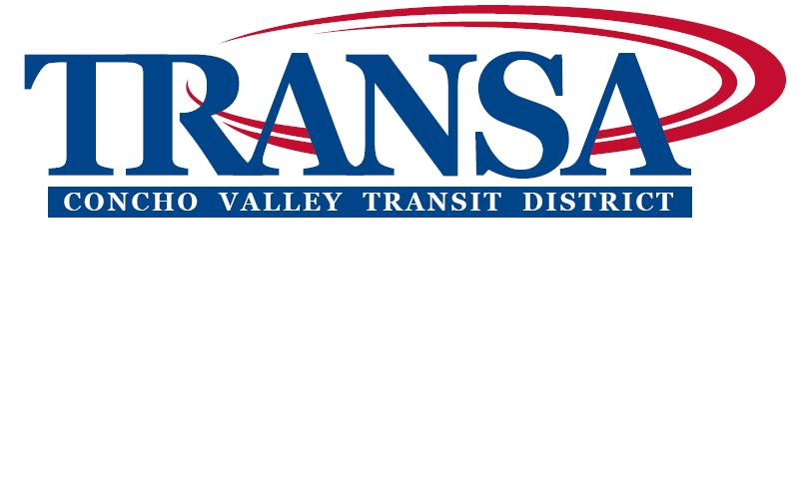

NOTICE OF A PUBLIC MEETING
CONCHO VALLEY TRANSIT DISTRICT

4:15 P.M.
Tuesday, November 20, 2012

Concho Valley Regional Conference and Training Center
2801 W. Loop 306, Suite A., San Angelo, TX 76904

The meeting place is accessible to persons with disabilities. If assistance is needed to observe or
comment, please call the CVTD office at 944-9666 at least 24 hours prior to the meeting.

BUSINESS

- DETERMINATION OF QUORUM AND CALL TO ORDER

- INVOCATION & PLEDGE OF ALLEGIANCE

- APPROVAL OF MINUTES of September 12, 2012 meeting (See Attachment A)

- APPROVAL OF CHECKS in excess of $2,000 written since the last meeting (See Attachment B)

- UPDATE on Route Information

- UPDATE on Status of Multi Modal Facility

- UPDATE on Status of the Medical Transportation Contract

- UPDATE on Plan to Review and Adjust Budgets

- UPDATE AND DISCUSSION of Line of Credit

- REVIEW AND ACCEPT Amended FY 2013 Budget Resolution 111412A (See Attachment C)

- AUTHORIZATION TO ACCEPT funds from TXDOT for an outside evaluation of the CVTD Resolution 111412B (See Attachment D)

- REVIEW Financial Reports/Balance Sheet (See Attachment E)

- DISCUSSION of next agenda board member designation and election of officers (See Attachment F)

- OTHER Discussion or future agenda items

- ADJOURN

Posted in accordance with the Texas Government Code, Title V, Chapter 551, Section .053, this Wednesday November 14, 2012.

Jeffrey K. Sutton, Executive Director CVTD

